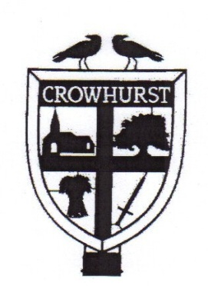
CROWHURST PARISH COUNCIL

Foodbank collection

Helping those less fortunate than ourselves

Christmas is a time for giving.

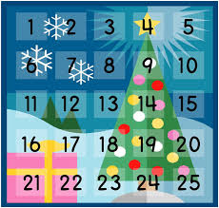 | We are collecting food donations for our local food bank.

We would like to give our contribution in time for Christmas and are therefore bringing collection forward to allow donation by 8th December. Any contributions received after this date will be donated in January.

If you can donate anything from 1 item to 24 items – for each day of advent we would appreciate it.

Please see https://eastgrinstead.foodbank.org.uk/give-help/donate-food/ for the latest items that the food bank is in need of and also please let Emma, the council clerk, know that you are participating by emailing: clerk@crowhurstonline.uk with your name and address so that we may arrange collection.
Thank you for your support.

