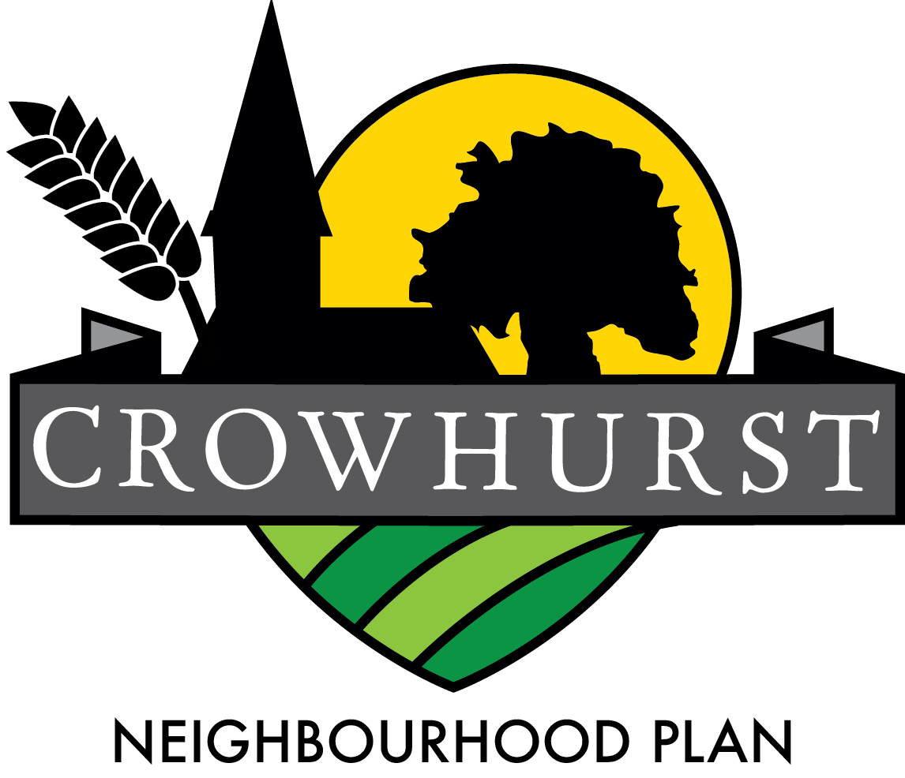
The Crowhurst Neighbourhood Plan, (Plan) which will shape the future of Crowhurst over the next 18 years, is in its final stages of development and we are now arranging a further and final consultation with the people of Crowhurst.
We have developed a set of policies, responding to your views and feedback throughout the process and would now like to hear any other comments you have prior to submitting the plan to Tandridge District Council for examination.

Neighbourhood Plans have to be taken into consideration by the district planning authorities, after this examination phase. Our Plan aims to protect our environment, permitting housing development only where it complies with the plan policies.
We will be presenting the plan at the Village Hall on Saturday 2nd December from 3pm – 5pm.
Please come along and help shape the future of our village.
The Plan has been developed to establish a vision for our village and to help deliver our local community’s aspirations and needs for the Plan period 2015, through to 2035.

Our plan has been produced by the Neighbourhood Plan Steering Group “NPSG” (a number of local residents, with the support of the Parish Council) using the views of the residents of Crowhurst. The NPSG has consulted with both residents and businesses, on a wide range of issues that will influence sustainability of our rural community. Every effort has been made to ensure that the views and policies contained within the Plan reflect those collected through engagement with Crowhurst residents and businesses.
Our vision is to maintain our agricultural legacy, rural environment and open spaces whilst highlighting our ancient heritage, promoting the community and character of Crowhurst and ensure that any development is in keeping with our environment and supportive of our vision and goals.
The Plan for Crowhurst reflects the contribution received from the community and in support of the vision focuses on some key goals:
- To maintain the open and rural nature of the Crowhurst countryside for future generations.
- To protect our parish assets and improve the local facilities for all age groups.
- To preserve the rural nature of the Parish and the openness of the countryside, whilst ensuring that any development is limited and meets the aspirations of current residents and facilitates the longer-term viability of the village.
- To continue to provide a good working environment for our core farming & niche businesses.
A copy of the full Neighbourhood Plan Document is available on the Community Website www.crowhurstonline.uk or a hard copy can be requested from any of the NPSG members (Lisa Siggery, Christine Pudney, John Doust, Ray Nuttall, Peter Jones, Louise Devine, Clare Hollingsworth, Kevin Siggery, Liz Lockwood, Emma Fulham).
Next steps:
- Consultation closes 31st January 2018
- Review consultation comments from the local community and official bodies;
- Fine tune any changes and submit to Tandridge for them check for compliance with planning law;
- Tandridge to conduct 6 week consultation with statutory bodies and Crowhurst on final plan and submit to an independent examiner;
- Once approved by the examiner, Tandridge to organize a referendum for all Crowhurst residents on the electoral roll, a simple majority passes the plan;
- Adoption by Tandridge as official planning policy for Crowhurst Parish.

