Footpath clearing event.
Saturday 3rd November -  10am from the church | 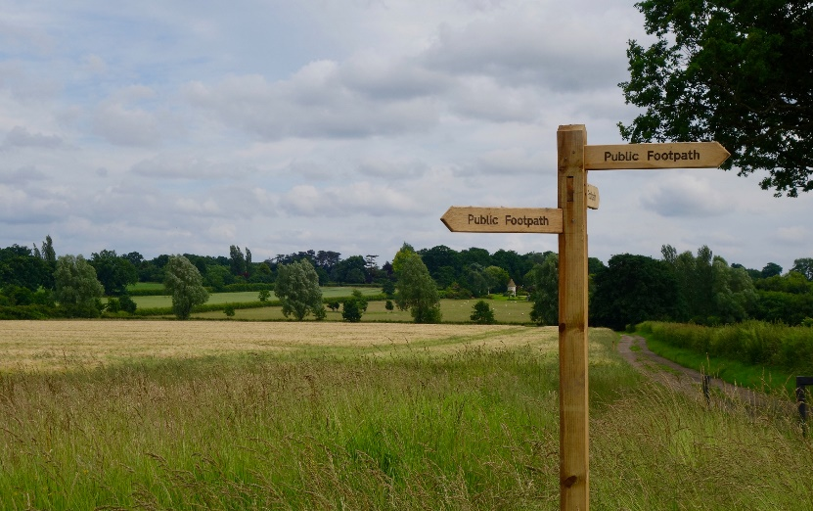

Help to keep your parish an attractive place to live and visit!

We are hoping to gather a working party to help clear two key footpaths in the Parish and your help would really be appreciated.

Please give just 2 hours of your time to help. Bring your own secateurs / hedge clippers / hand saw and gardening gloves.

